**Name: Session:**

**Programming II**

**Lab Exercise 3.9.2022**

1. Serendipity Booksellers has a book club that awards points to its customers based on the number of books purchased each month. The points are awarded as follows:

* 0 books = 0 points
* 1 book = 5 points
* 2 books = 15 points
* 3 books = 30 points
* 4 or more books = 60 points

Create an application that lets the user enter the number of books purchased this month and displays the number of points awarded.

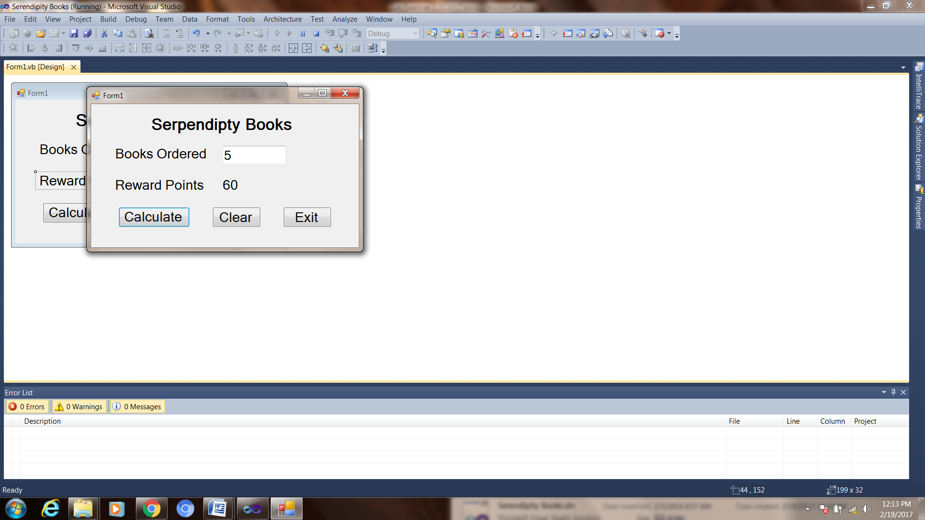

1. Modify program 2 from Lab Exercise 3.7.2022. Modify the form so that it has a checkbox captioned Display Potential Savings. When the check box is selected, the application should display the amount of money a Package A customer would save if they purchased Package B or C or a Package B customer would save if the purchased Package C.

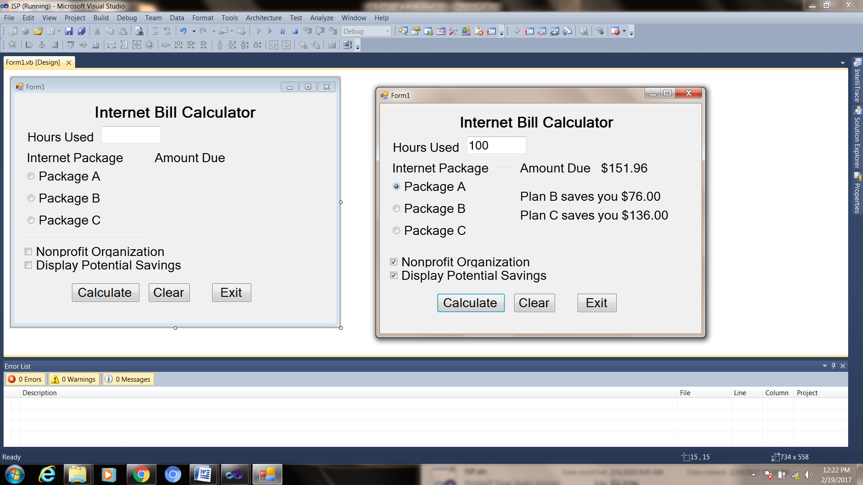

Panel Control

**When you have completed problem 1 and 2, submit their source code and a screen shot of your running applications.**